Exercise 2.4 Report: Model Optimization Summary

# 1. Introduction

This report summarizes the outcomes of three machine learning models developed and optimized to predict pleasant and unpleasant weather using historical weather data. The models include: Random Forest (Notebook 1), Convolutional Neural Network (CNN, Notebook 2), and Recurrent Neural Network (RNN, Notebook 3). Each model underwent tuning to enhance predictive accuracy using the VALENTIA weather station dataset, or all stations for Random Forest. The aim is to identify the strengths of each approach and evaluate their classification performance.

# 2. Random Forest Model Summary

The Random Forest model was trained using data from all weather stations. After hyperparameter optimization, the model showed high accuracy in distinguishing pleasant from unpleasant weather. The confusion matrix showed 4362 correct predictions for unpleasant days and 197 for pleasant ones, with only 31 pleasant days misclassified.

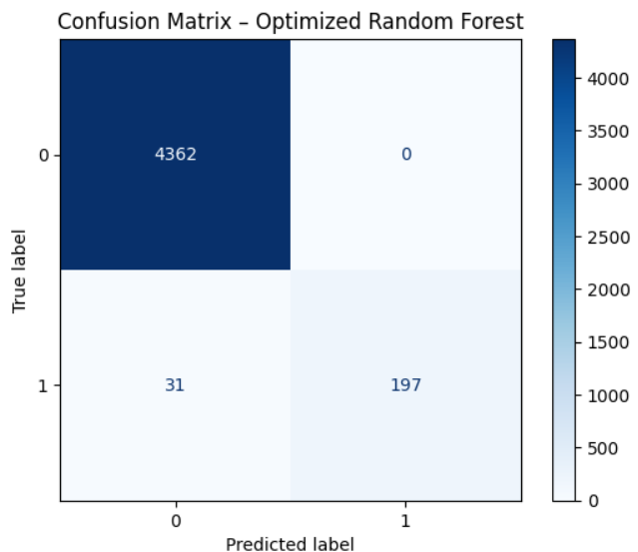

Fig: Random Forest Model Confusion Matrix

Feature importance plots revealed that temperature-related features, especially from the VALENTIA station, played the most critical role in prediction. The top 15 features mostly involved temperature, sunshine, and humidity.

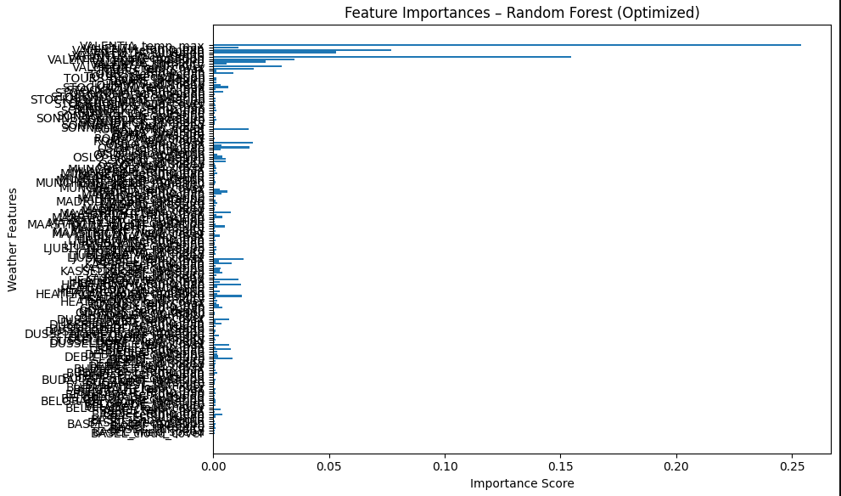

Fig: Random Forest Optimized

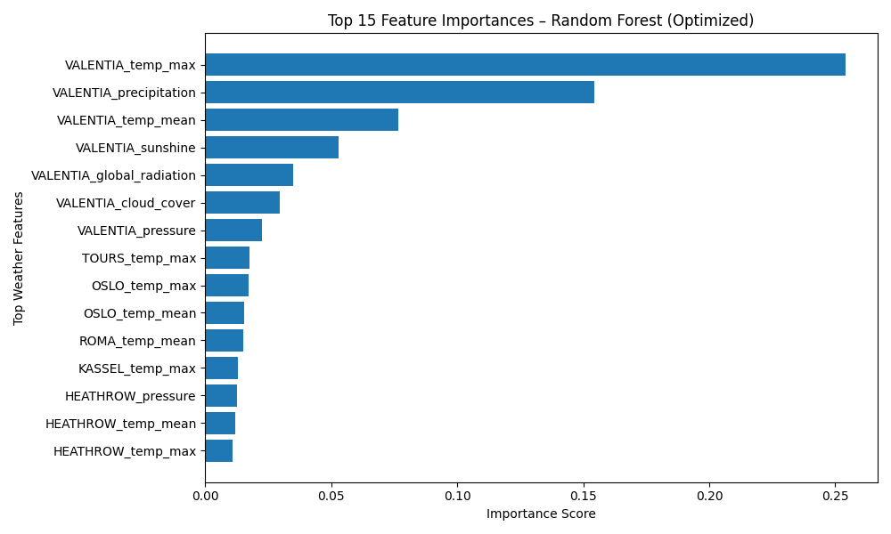

Fig: Random Forest top 15

# 3. CNN Model Summary (VALENTIA Station)

The CNN model was trained using weather time-series data from the VALENTIA station. After tuning, it showed limited ability to predict pleasant weather accurately, though it was strong in detecting unpleasant weather.

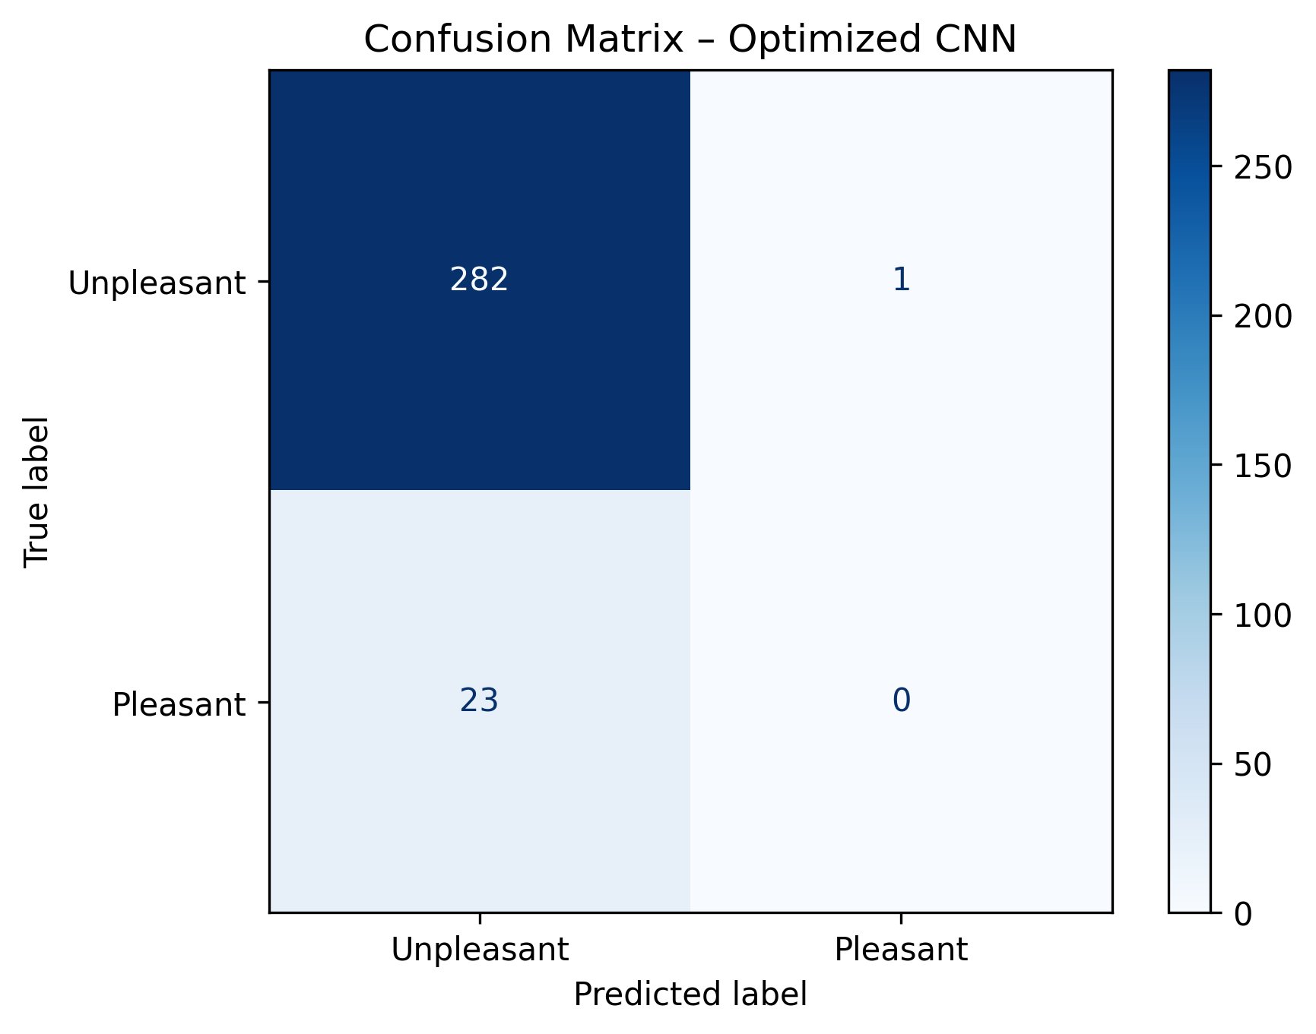

Fig: Optimized CNN Confusion Matrix

The confusion matrix illustrates the model's conservative nature. While it accurately predicted most unpleasant days, it missed all pleasant weather days.

# 4. RNN Model Summary (VALENTIA Station)

The optimized RNN model displayed more balanced performance compared to CNN. With an overall accuracy of 98%, the model successfully predicted 116 out of 228 pleasant days and 4354 unpleasant days.

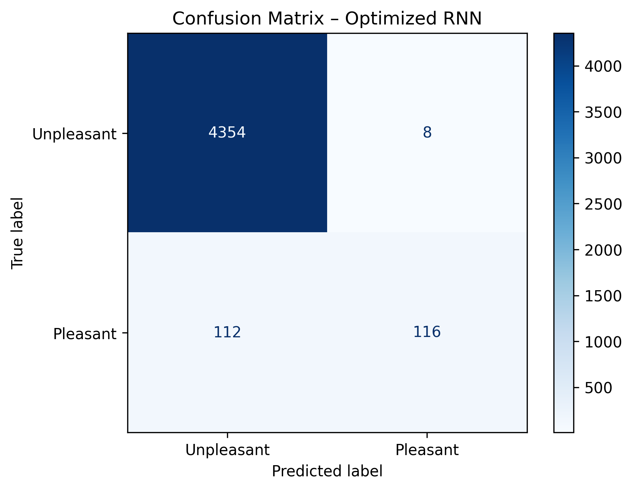

Fig: Optimized RNN Confusion Matrix

This suggests the RNN learned patterns in time-series data better than the CNN. It balances performance for both weather categories, though there's still room for improvement in detecting pleasant days.

# 5. Final Notes and Comparison

Among the three models, Random Forest offered the highest interpretability and stability across all stations. RNN showed stronger performance on the temporal VALENTIA data than CNN, suggesting its suitability for time-based weather patterns. CNN lagged in recognizing pleasant weather. Future improvements could combine RNN's temporal handling with Random Forest's feature strength.